[**Group 16 - Web Wizards**](https://brightspace.algonquincollege.com/d2l/lms/dropbox/user/folder_submit_files.d2l?db=503418&grpid=558232&isprv=0&bp=0&ou=495165): Movie Palace Assignment 2

***Project Description:*** Movie Palace is a web application that allows users to search for their favourite movies, view information about them, and rent them. Users can also view their rented movies on a separate page.

***Web Map:*** The web application consists of four pages: the search movies page (index.html), my movie list page (mymovies.html), and the login/signup page (loginpage.html) also (aboutus.html) page.

1. *Project Structure*

* loginpage.html: The login and signup page for user authentication.
* The project is organized into the following files:
* index.html: The main search page where users can search for movies and view their details.
* mymovies.html: The page displays the user's rented movie list.
* about.html: The page containing information about the Movie Palace application.
* style.css: The main stylesheet for the project.
* login.css: The stylesheet is specific to the login and signup page.
* script.js: Contains the JavaScript code for searching and renting movies.
* key.js: Contains the OMDB API key.
* login.js: Contains the JavaScript code for user authentication.

(detailed explanation of the UX functionality can be found in User Interface Functionality Guide)

***Design Guide***:

The colour scheme of the website is based on shades of black, with a reddish background and black-and-white text. The navbar has a black-gray background with orange logo text, and the buttons are also orange text. The social media icons are white on a black and grey background.

* Background color for the body element: #986c6c
* Font color for the body element: #FFFFFF
* Font family for the body element: Arial, sans-serif
* Background color for the navigation bar: #333
* Font color for the navigation links: #ffb92a
* Font size for the navigation links: 16px
* Background color for the "Rent This Movie" button: #ffb92a
* Background color for the footer: #333
* Font color for the footer: #FFFFFF
* Font size for the footer: 16px

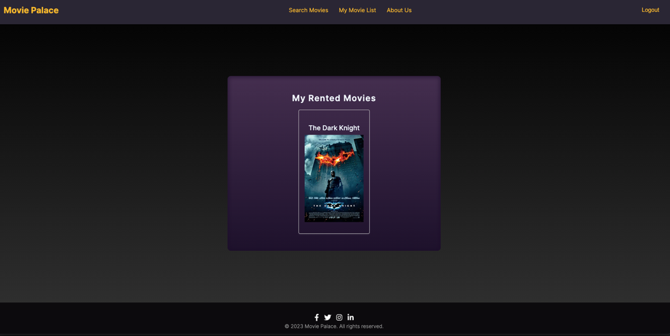

***User Interface Functionality Guide:***

1. Search Movies Page (index.html):

• Users can search for movies using the search bar and clicking the search button.

• The results are displayed below the search bar, and if the movie exists in the database, information about the movie is displayed.

• Users can rent a movie by clicking the "Rent This Movie" button, which saves the movie to their rented movies list.

• Users can view their last searched movie at the top of the page.

2. My Movie List Page (mymovies.html):

• Users can view a list of their rented movies, which is displayed in a grid layout.

• If the user has not rented any movies, a message is displayed stating that no rented movies were found.

3. Login/Signup Page (loginpage.html):

(ATTENTION TO THE FIRST STEP)

• Users can enter their username and password to login, or sign up by entering a new username and password and clicking the "Sign Up" button.

• If the user enters an incorrect username or password, an error message is displayed.

• If the user signs up successfully, a message is displayed stating that they can now log in.

• When the user logs in or signs up, the navbar displays a "Logout" button.

Overall, the website is designed to be simple and user-friendly, with a focus on ease of use and functionality.

4. About Us Page (aboutus.html):

• The About Us page provides information about the creators of the Movie Palace web application.

• The page includes a brief introduction about the company and its mission.

#Notes

* Group members has worked together on some tasks so that every member experience the other roles.